I am writing to request help with a DataClient licensing issue deploying our C# HMI App (.net4.8 Framework, 32-Bit App, deployed to Windows 10 Pro), and could use some help straightening it around. Please help me to get the .net app licensed correctly. I followed the documentation on how to license the app as a resource as per the Managed Resource License store documentation, adding it to the HMI Application HMI namespace (See pics at end of document for license install method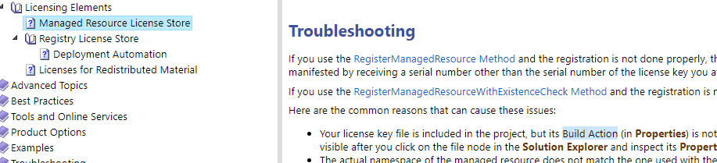
Here is the C# code to handle licensing in the HMI application:
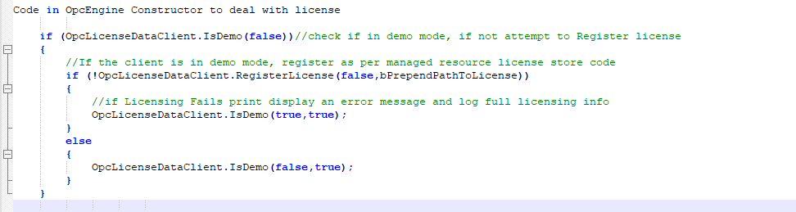
The above code first determines if the client is in demo mode, attempts to register it, and then checks the license again (note: function code is found in pics in the material following). If after attempting to register the license, if still in demo mode it displays an error message and also logs license details.
The following is output in the log from the code:
OPC DataClient is a stock demo or trial license. (license# SerialNumber: 1111111120)
Attempting to register HMI.Key-Permanent-WebForm-1999326390-20220224.bin
AppName 1880_HMI Executing Assembly Prtlib
HMI OPC DataClient Licensing info:
Multipurpose.ID: Multipurpose
Multipurpose.SerialNumber: 1111111120
Multipurpose.SubjectName: *
Multipurpose.IssuerName: OPC Labs
Multipurpose.NotBefore: 1/1/1601 12:00:00 AM
Multipurpose.NotAfter: 1/1/1601 12:00:00 AM
Multipurpose.RunTimeLimit: 00:30:00
Multipurpose.RunOnServer: 1
Multipurpose.AllPurposeStations: 1
Multipurpose.ExtraRuntimeStations: 0
Multipurpose.Type: Trial License
Multipurpose.CallerRestrictions: System.String[]
Multipurpose.Hidden: 1
Multipurpose.OptionRestrictions: System.String[]
Multipurpose.PlatformRestrictions: System.String[]
Multipurpose.ReleaseDateCovered: 1/1/1601 12:00:00 AM
Multipurpose.VersionNumberCovered: 562
Multipurpose.DegradeDate: 12/15/2022 12:00:00 AM
Multipurpose.IsEvaluation: 1
OPC DataClient is a stock demo or trial license. (license# SerialNumber: 1111111120)

Here is an message I got in the debugger regarding the licensing:
OpcLabs.EventTracing.LogEntries Error: 1 : LogEntry("OPCLabs-EasyDAClient",Error,0,1202). License validity check for EasyDAClient component has failed. Not allowed to run by the license "Multipurpose". You might be running a trial license, and the version of the software you are using is obsolete. To resolve this problem, a) obtain a recent version, or b) ask for an evaluation license key, or c) install a license valid for the current version. Product information follows. Component name: "QuickOPC", license IDs: "Multipurpose", version number: 562, release date: 11/13/2021, trial validity: 397 days, option expression: "EasyDAClient". Context: 0 dropped license(s).
Here is the code that determines if the license is valid:
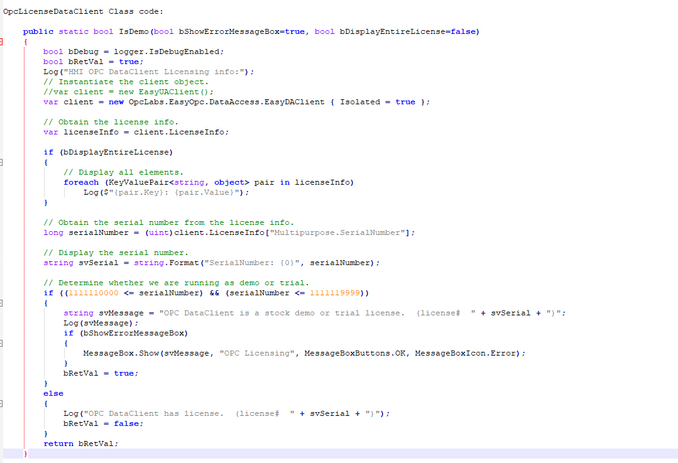
Here is code I generated from the CSharp Example Classes and Software Toolbox Webdoco to register the license using the resource name as: HMI.Key-Permanent-WebForm-1999326390-20220224.bin or the fully qualified namespace path.
Note: bPrependSubdirectory is false in code below

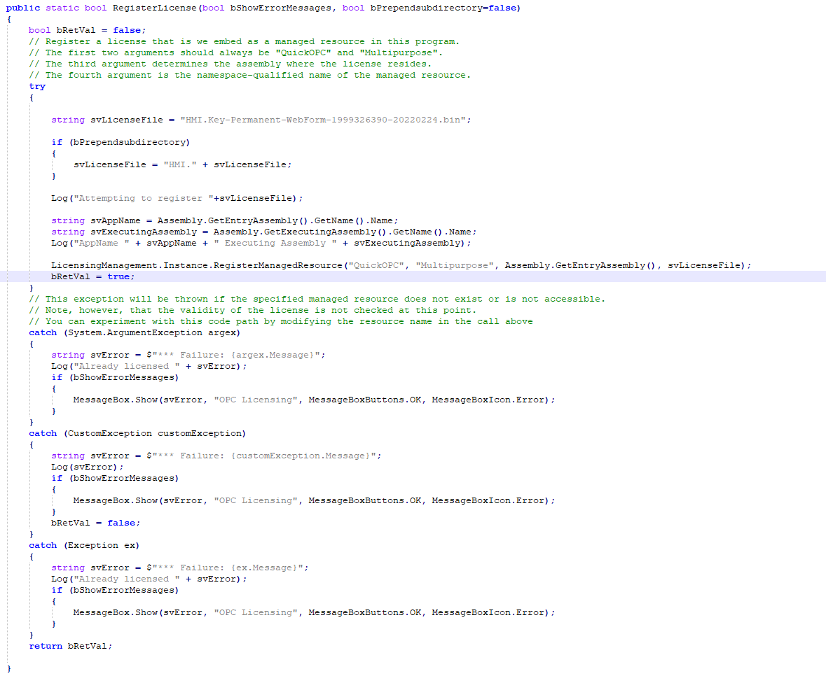
I used the following method to install the license binary for Data Client License via Managed Resource License Store.
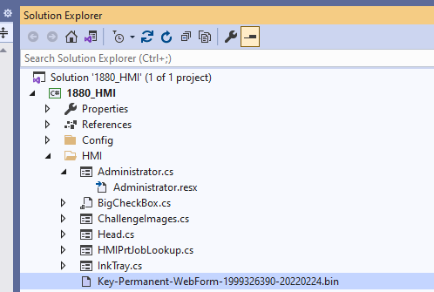

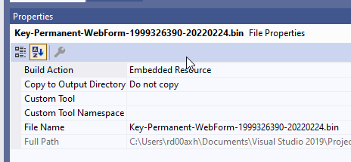

Concerns:
- Could not link LicenseManageent.Instance.RegisteredManagedResourceWithExistanceCheck() function had to use LicenseManageent.Instance.RegisteredManaged().

- I am assuming I am not executing the registration correctly somehow, such as invalid parameters. I have tried some different things. Is there something I am missing?

- I am using EasyDAClient to check license, not EasyUAClient (see last code sample), is this correct?

