PRESS “WINDOWS + R” and type DCOMCNFG, Press enter
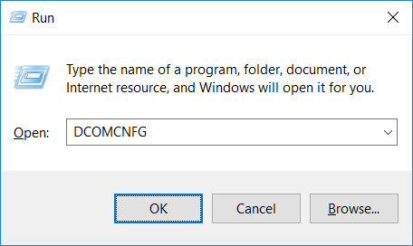

Select computers tab, and My Computer From Sub-sequent Menu.
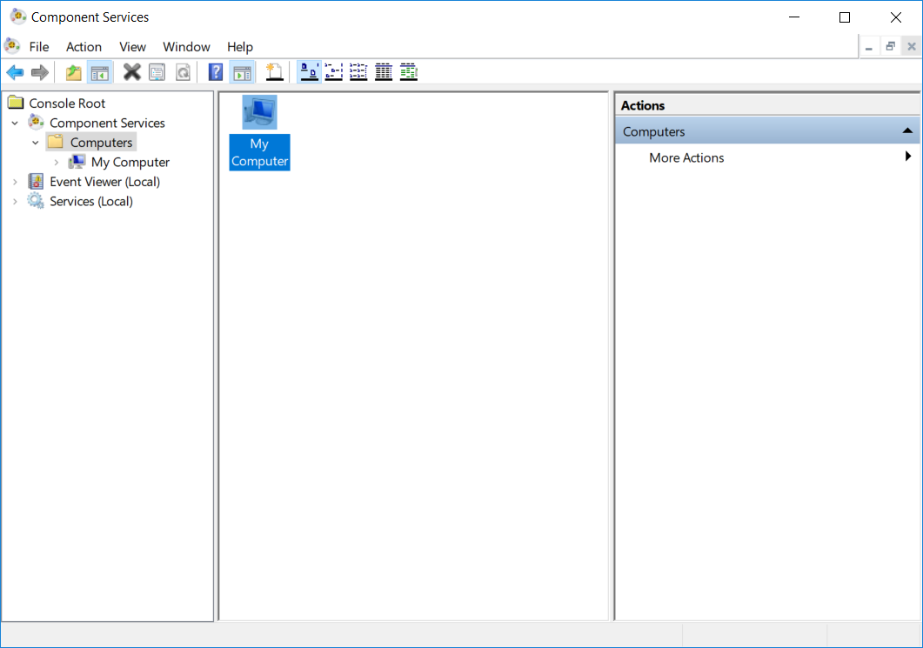
Right click on My Computer, Go To properties.
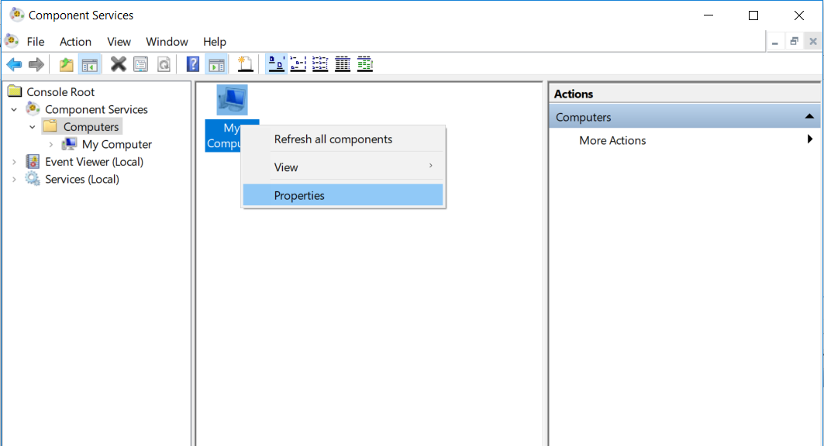

Go to Default Properties tab,
1 ) Enable Distributed COM on this Computer.
2 ) Set Default Authentication Level to NONE
3 ) Set Default Impersonation Level to IDENTIFY.
APPLY these setting and press OK.
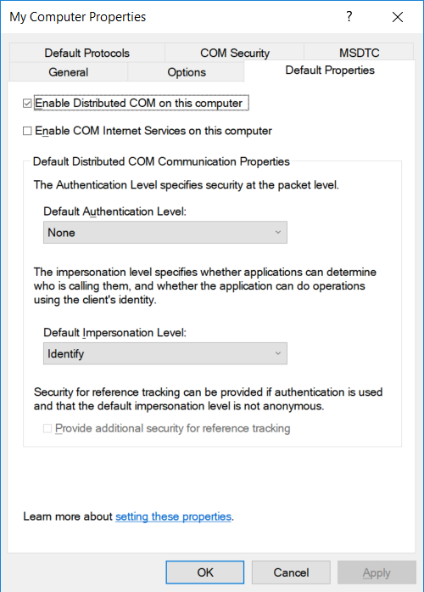
Go to COM Security Tab, In Access Permissions Menu, Click on Edit Default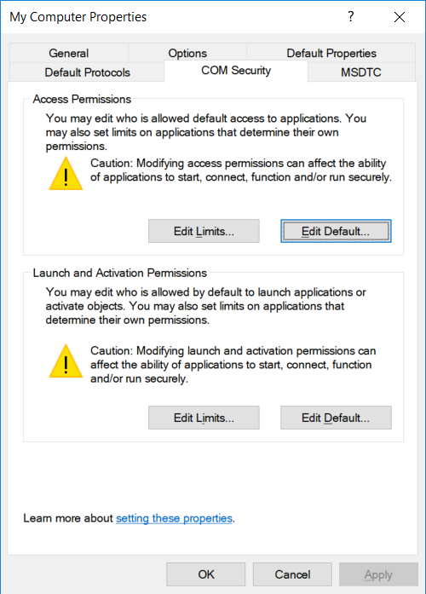
From resulting window make Sure that User EVERYONE & ANONYMOUS LOGON are present,
And having local and remote access, ( If not then add users manually and give permissions/access.)
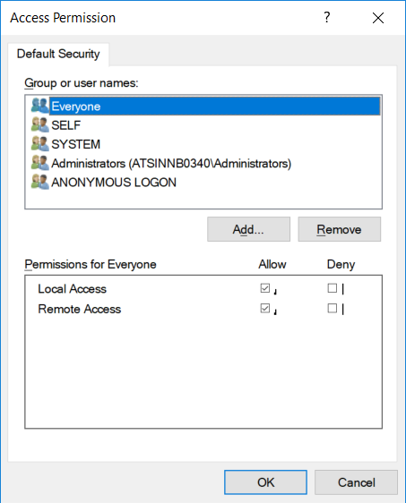
Repeat the same procedure for Launch and Activate Permissions tab (in COM Security Tab)
i.e. If required add users EVERYONE & ANONYMOUS LOGON and Give LOCAL & REMOTE ACCESS.
Expand My computer and go to Dcom-Config. & select OPCENUM & go to properties.
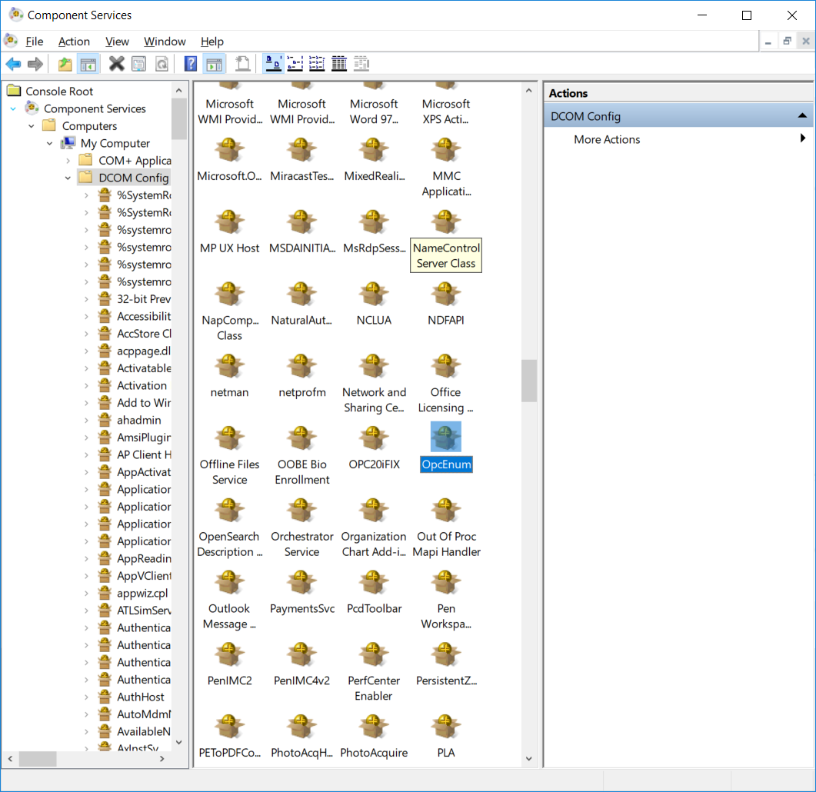

In General Tab, Set Authentication to NONE.
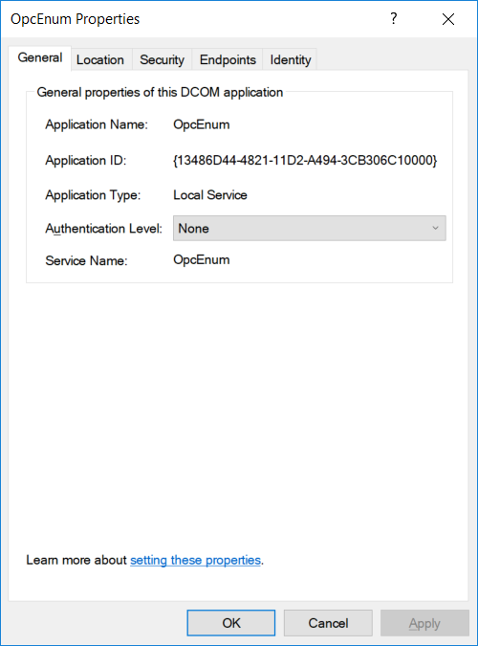

In location Tab, Set Run application on this Computer.
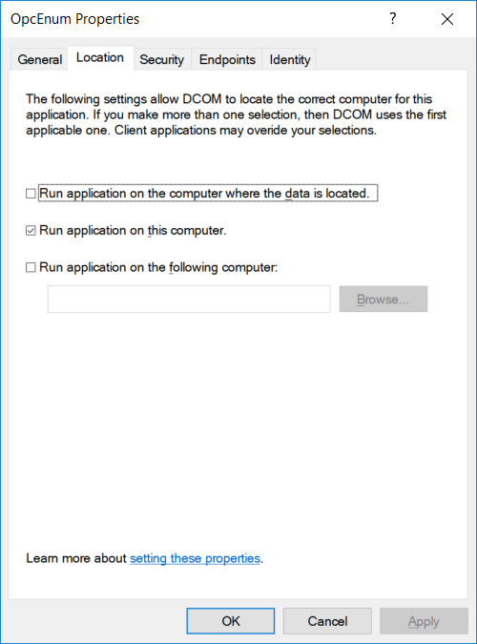
In Security tab, Keep launch and activation permissions and access permissions as USE DEFAULT.
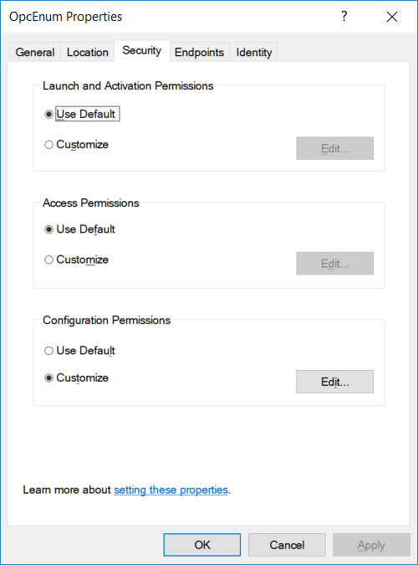
Go to Config Permissions, EDIT.

Add users “EVERYONE & ANONYMOUS LOGON” and give all permissions.
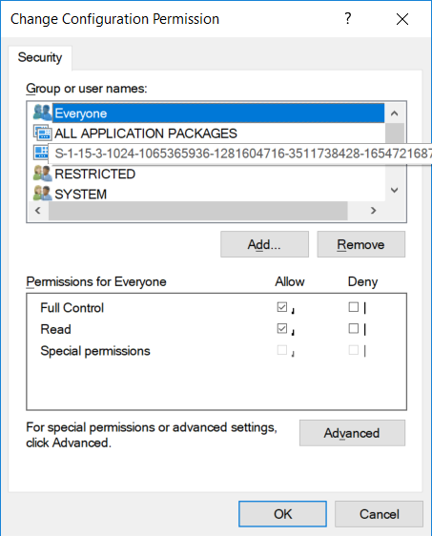

In Identity Tab, select System Account (service only).
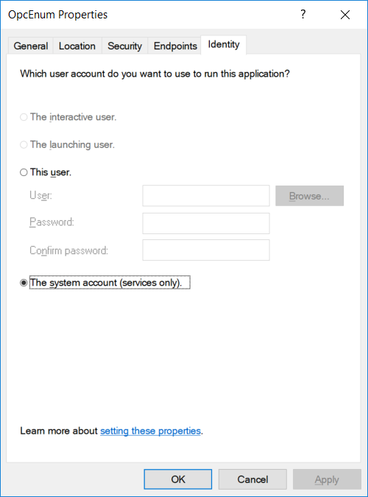

Again Expand My computer and go to Dcom-Config. & select KEPSERVEREX & go to properties.
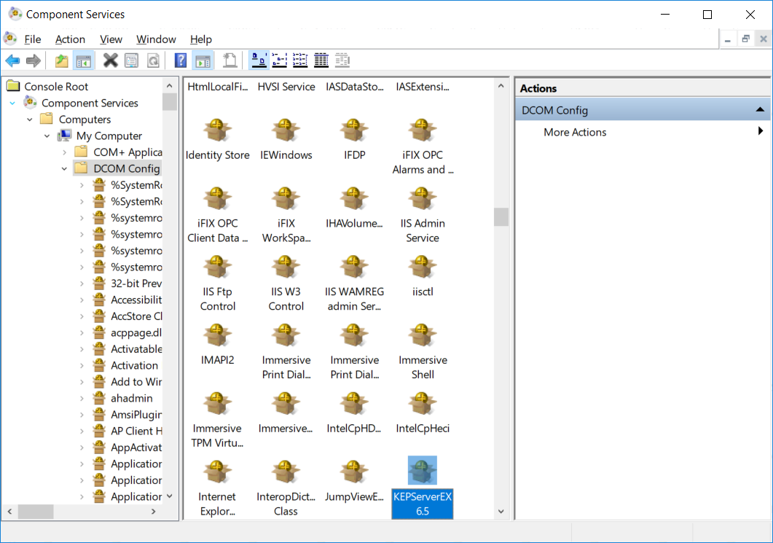
In General Tab, Set Authentication to NONE.
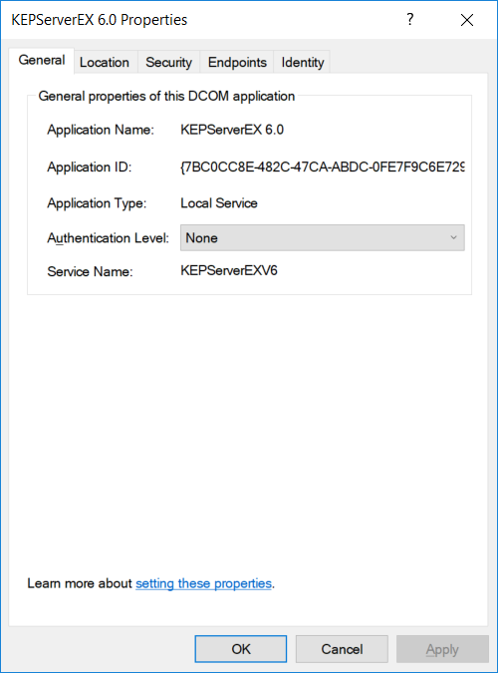

In location Tab, Set Run application on this Computer.
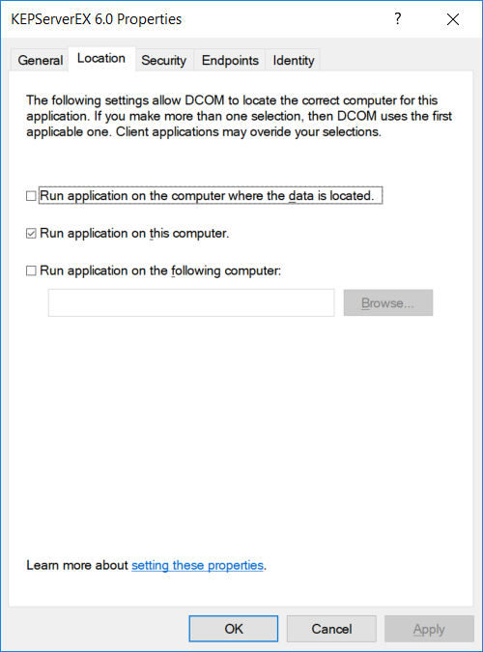
In Security tab, Keep launch and activation permissions and access permissions as USE DEFAULT.
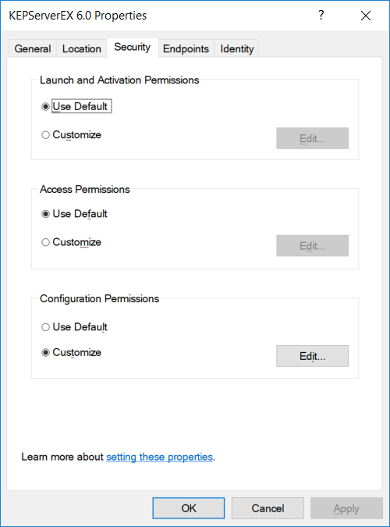
Go to Config Permissions, EDIT.

Add users “EVERYONE & ANONYMOUS LOGON” and give all permissions.

In Identity Tab, select System Account (service only).

Now go to control panel, administrative tools, local security policy
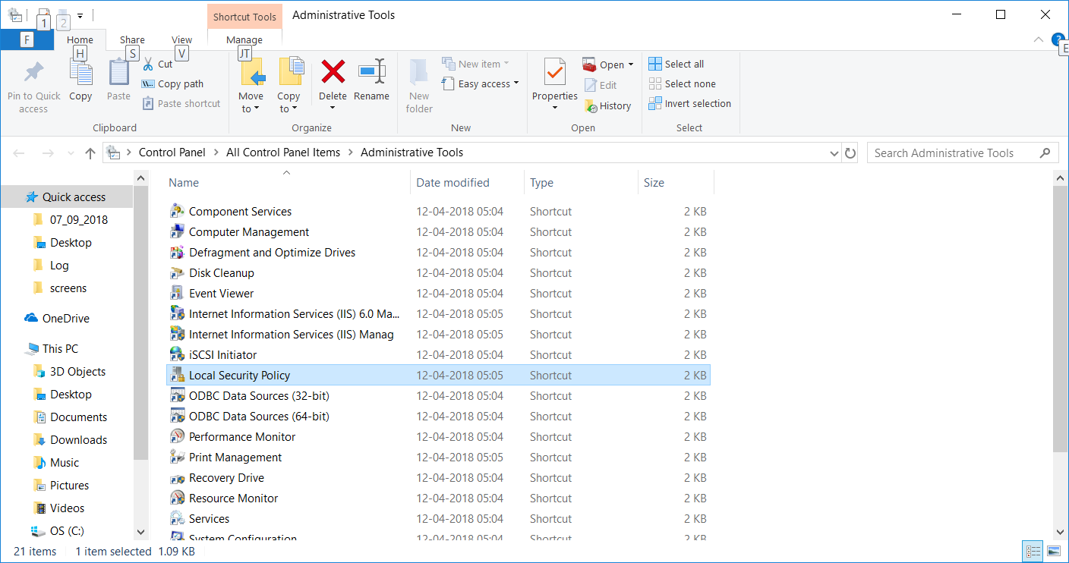
Select Local policies, security Options. And DCOM setting highlighted in yellow are NOT DEFINED
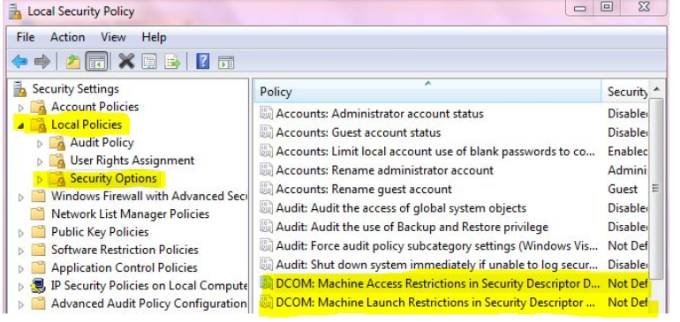

Now, Right click and go to properties of Network Access:let everyone permission apply to anonymous login & change the local security setting (Select Enable).
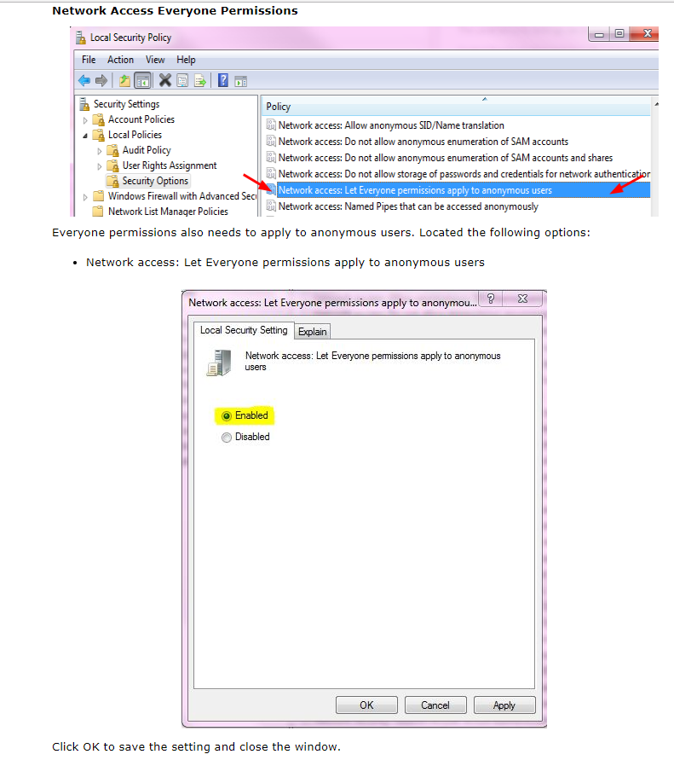

Select Network Access : Sharing and Security for local accounts., ( Go to Properties. )
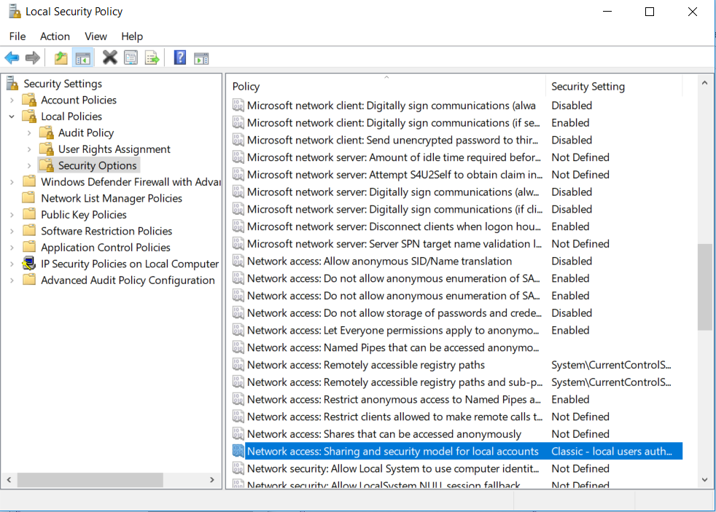
Set Classic – Local Users Authentication as Themselves, in Local Security Setting Tab
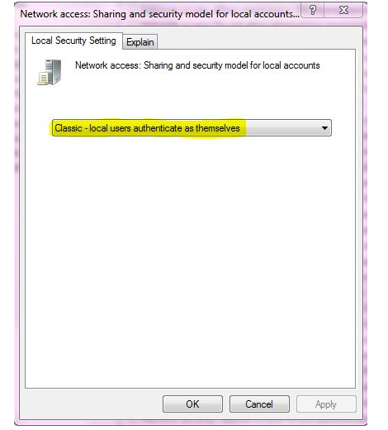

Make sure that OPCENUM service is Running.
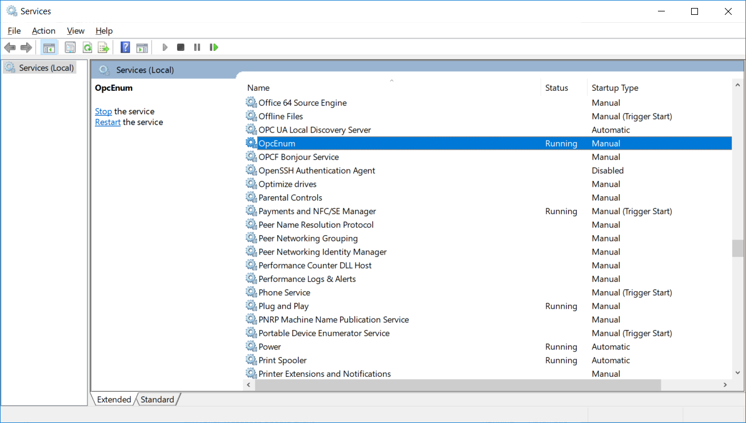

Kepware Configuration
