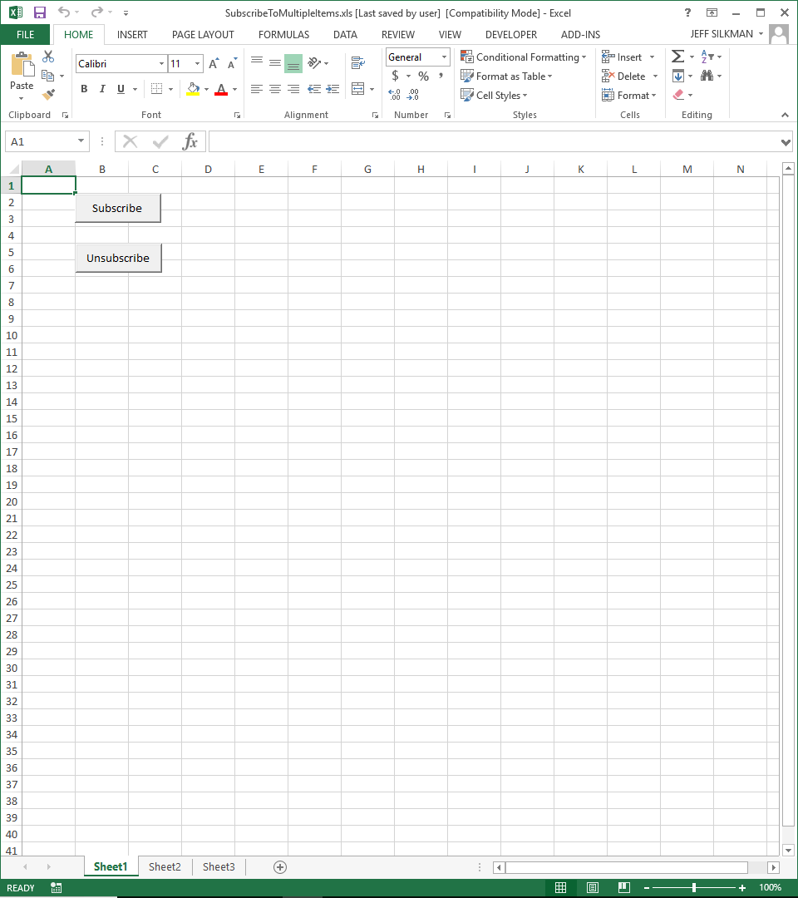
Stepping through with debugger, application crashes when CALL Client.SubscribeMultipleItems (arguments) is executed.

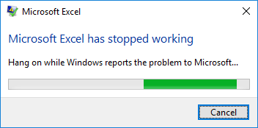
RESULT OF PRESSING “SUBSCRIBE” BUTTON.

